**Experiment 10**

**Aim:**

Experiment to study any one BI tool such as Pentaho, Tableau and QlikView.

**Theory:-**

Tableau is a powerful data visualization and business intelligence tool that allows users to connect, visualize, and share data in a way that provides insights and supports decision-making. Tableau allows users to create interactive dashboards, reports, and charts, and provides a user-friendly interface for exploring data and generating insights. Tableau can connect to a variety of data sources including spreadsheets, databases, and cloud-based data sources, and offers a range of visualization options, from simple bar charts to complex heat maps and scatter plots. It is widely used in industries such as finance, healthcare, and marketing to analyze data and make informed business decisions.

To create visualizations in Tableau, you can follow these general steps:

1. Connect to your data source: Tableau supports a wide range of data sources, including spreadsheets, databases, cloud services, and big data sources.
2. Drag and drop fields: In the worksheet area, you can drag and drop fields from the data pane onto the rows and columns shelves, and onto the marks card to define the type of visualization.
3. Choose a visualization type: Tableau offers a variety of visualization types, including bar charts, line charts, scatter plots, heat maps, and more. You can choose a visualization type by clicking on the corresponding icon in the "Show Me" panel.
4. Customize the visualization: You can customize the visualization by adding filters, sorting, and formatting options. You can also add calculations and create groups to further analyze the data.
5. Save and share the visualization: Once you have created the visualization, you can save it in various formats, including Tableau workbook files, image files, and PDFs. You can also share the visualization with others by publishing it to Tableau Server or Tableau Public.

Tableau provides a user-friendly interface and a range of tools to create interactive and visually appealing dashboards and reports for data analysis and presentation.

Tableau is a data visualization and business intelligence software that helps people see and understand their data. Some of the key features of Tableau are:

1. Drag-and-drop interface: Tableau provides a simple and intuitive drag-and-drop interface that allows users to quickly create visualizations without writing any code.
2. Data blending: Tableau has the ability to blend data from multiple sources and formats, allowing users to combine different datasets into a single visualization.
3. Interactive dashboards: Tableau's interactive dashboards allow users to create visualizations that can be explored and manipulated in real time, giving users the ability to drill down into their data and uncover insights.
4. Storytelling: Tableau allows users to create compelling data stories by combining multiple visualizations and adding narrative to guide the viewer through the data.
5. Mobile and web compatibility: Tableau allows users to create visualizations that are compatible with both mobile devices and the web, making it easy to share insights and collaborate with others.
6. Advanced analytics: Tableau has advanced analytics features such as predictive modeling, statistical analysis, and forecasting that allow users to go beyond simple visualizations and gain deeper insights from their data.
7. Real-time data integration: Tableau can connect to real-time data sources and provide real-time visualizations, making it useful for monitoring and tracking live data streams.

**Screenshots of implementation:**

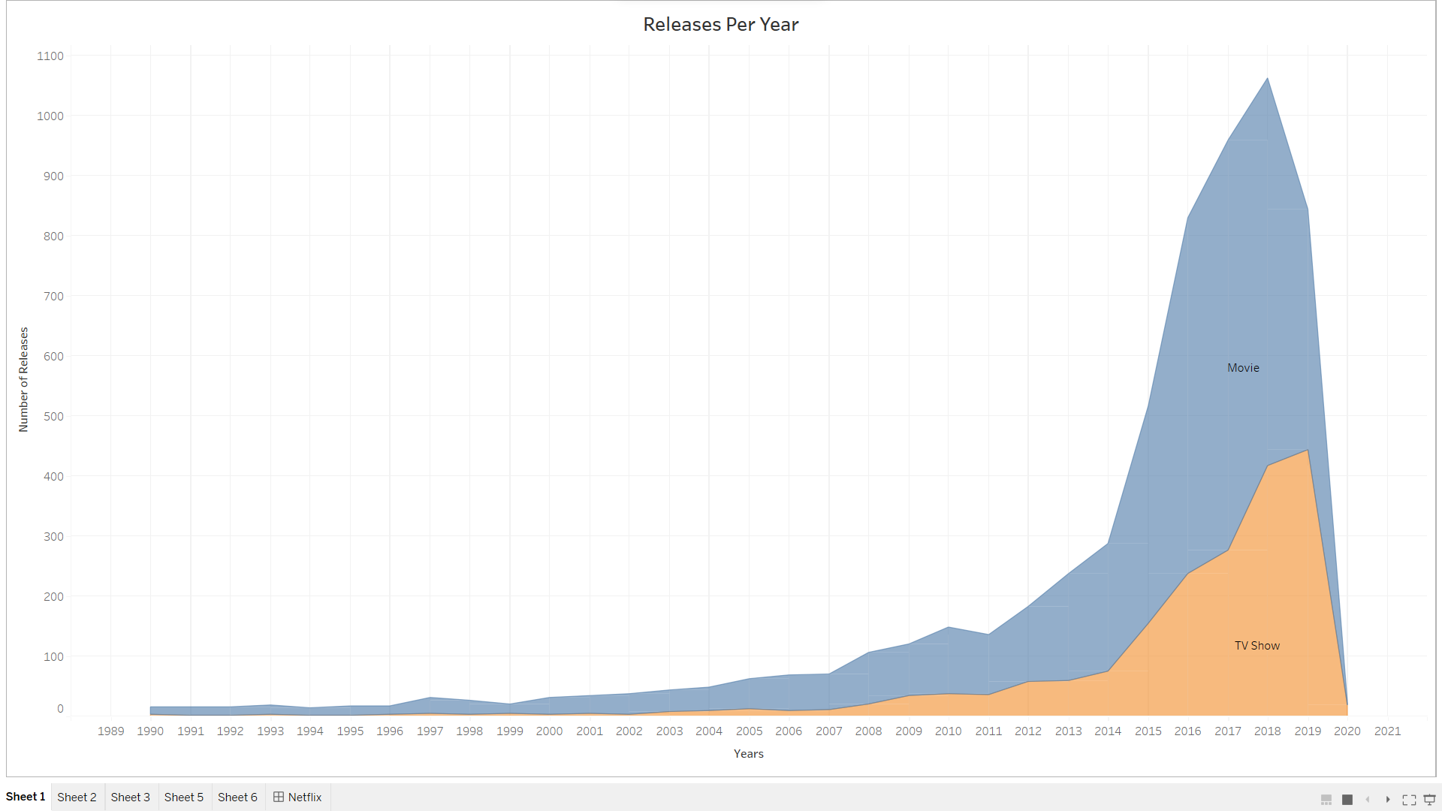

The number of movies and shows released increased a lot in the last few years. We can conclude that in the last few years there has been a large growth in the entertainment industry.

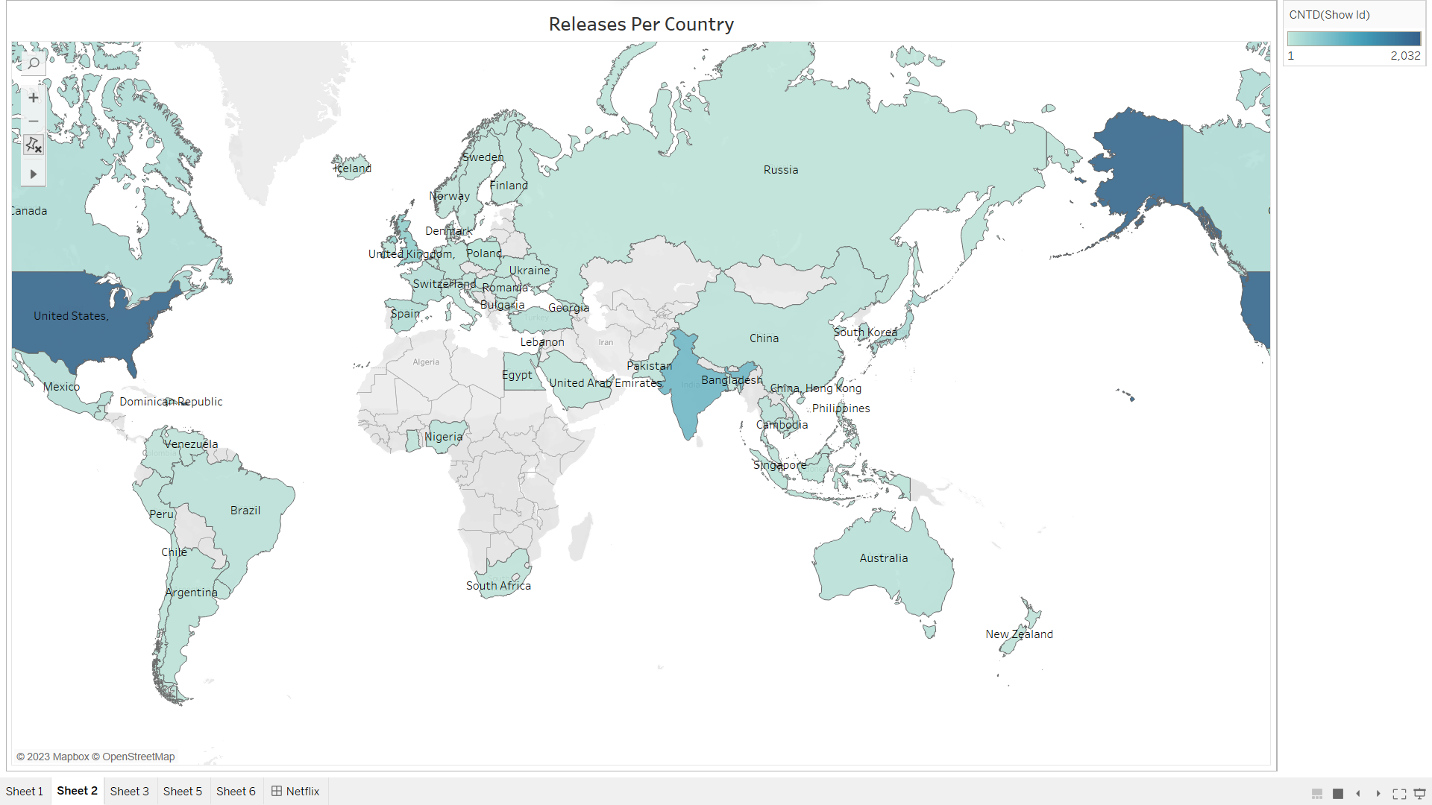

We can see that most released movies and tv shows are from the United States of America followed by other countries like Canada, India, China, Russia etc.

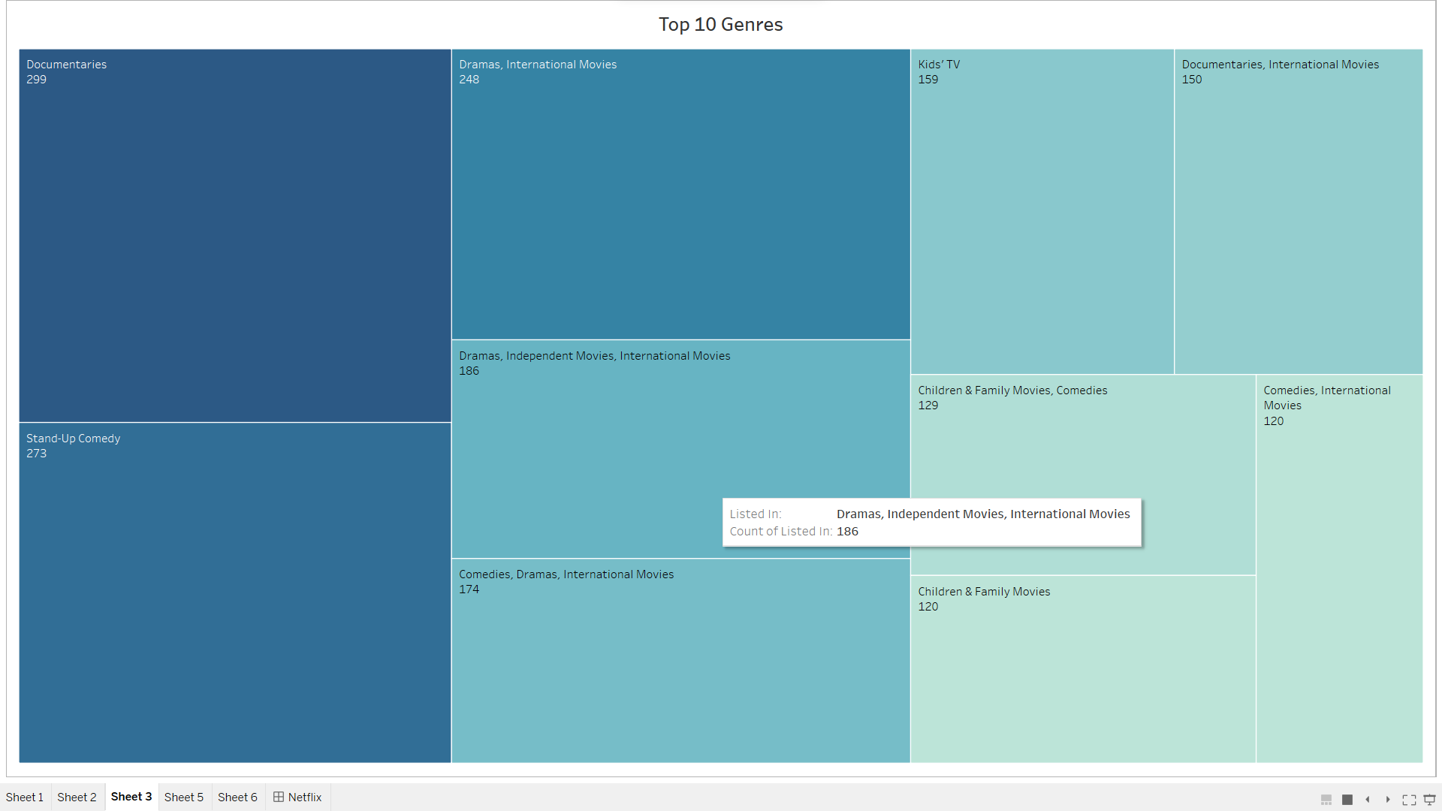

Documentaries, stand-up comedy, and dramas are the top 3 genres. They account for the most films and shows.

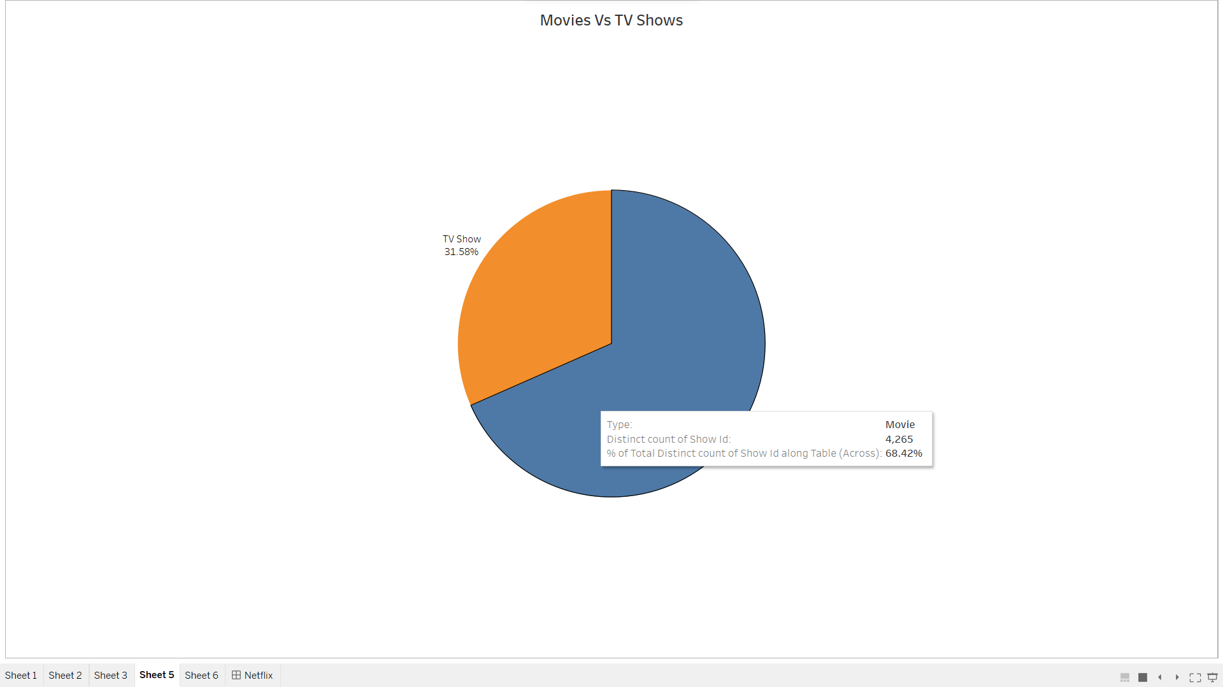

The number of movies released is far more than the number of tv shows. People prefer watching movies over tv shows as movies are less time consuming.

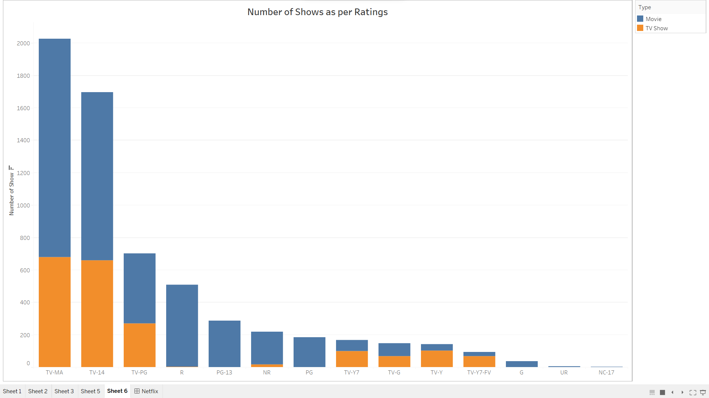

Most of the content can be watched by adults as well as kids. This helps to target a large number of people which helps to increase the profits for the organization.

This the dashboard containing all the visualizations in one place. This can be helpful to read, analyze, understand and draw conclusions from.

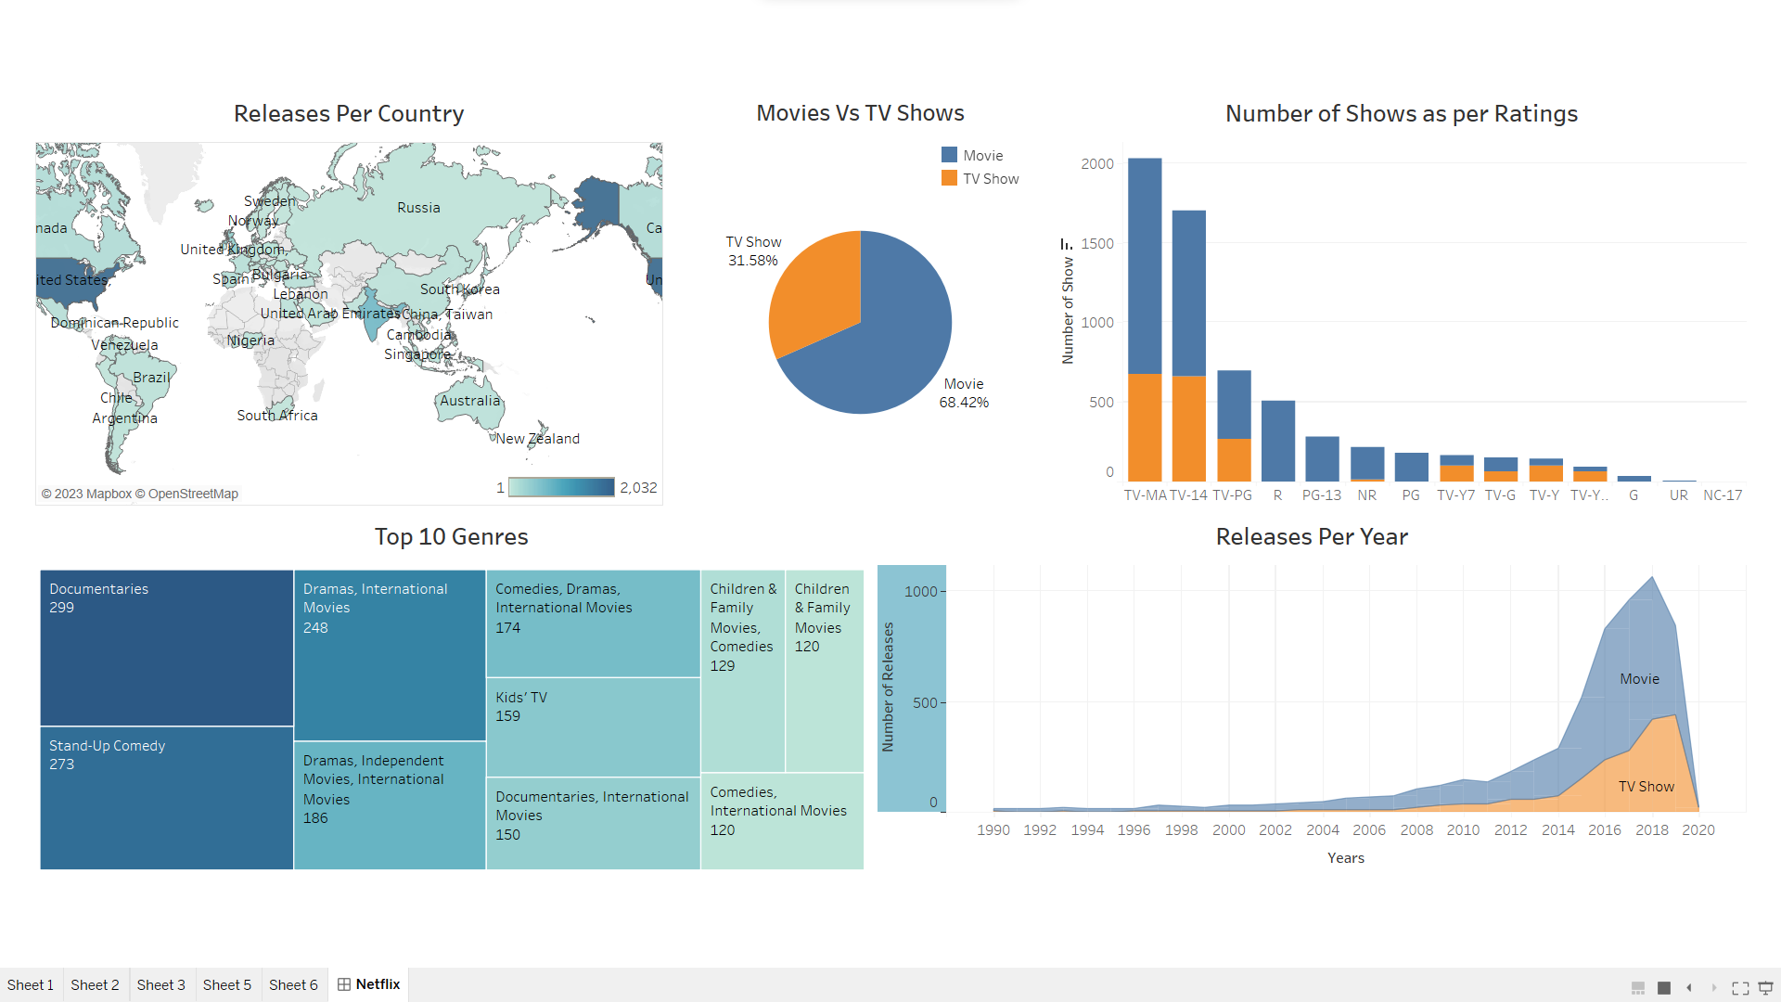

**Conclusion-**

Thus we have successfully used tableau to visualize the data and create a dashboard based on the visualizations.